Version Control

Samuel Cooke – s251388

Repository Link
Link: https://github.com/s251388/AIE-2.2.1-Linear-Search.git
Screenshot:
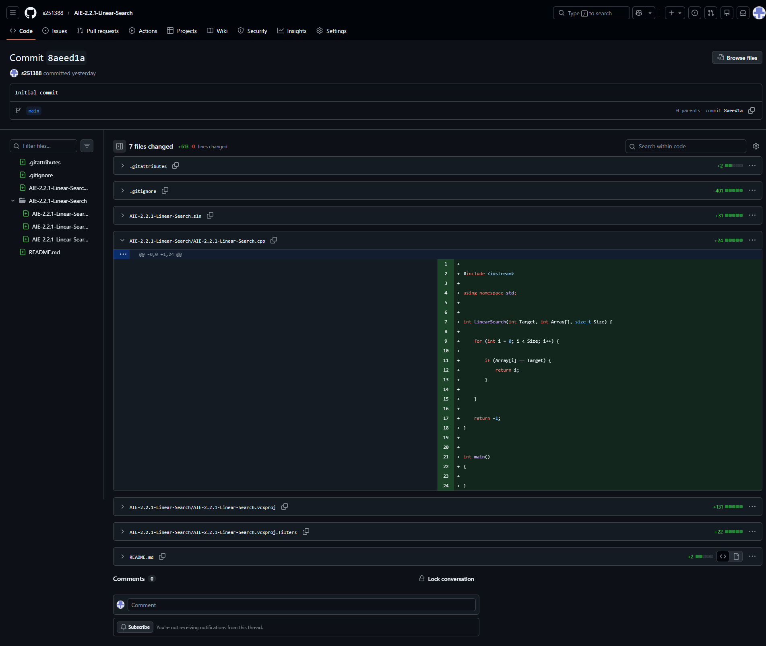
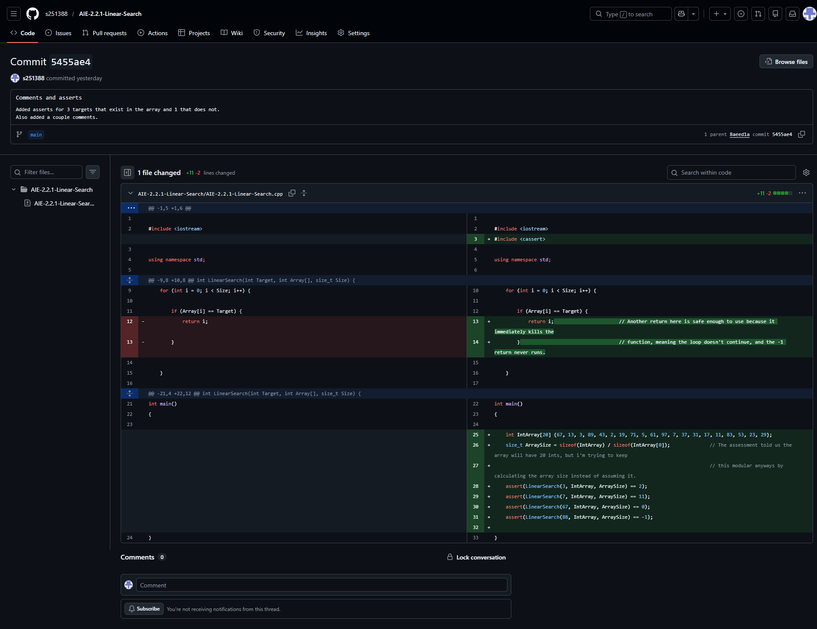
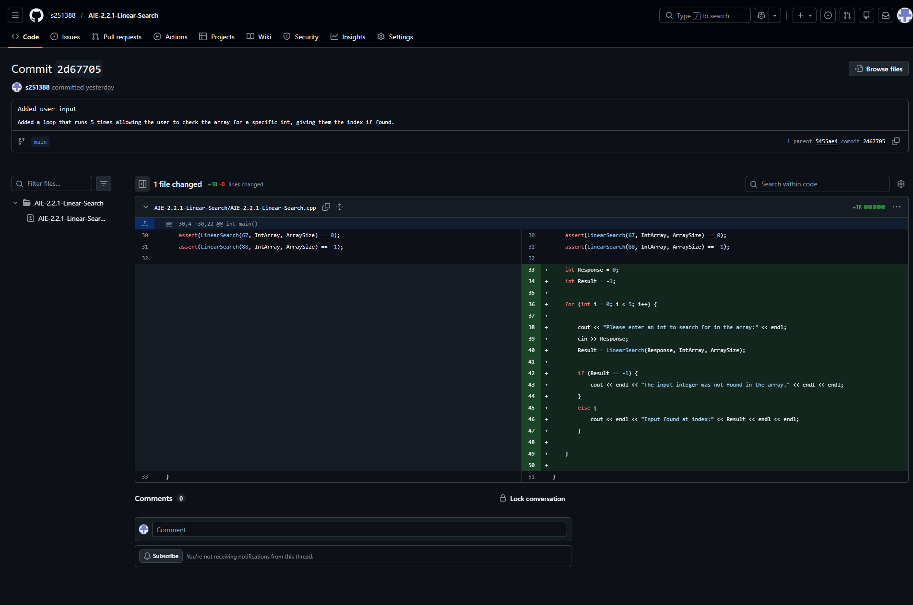

Resources:
- Linear Search: https://www.geeksforgeeks.org/dsa/linear-search/

Challenges
Write a description of the challenges, mistakes made, or problems you personally encountered, and what you did to overcome, work around, or resolve these issues. (100 - 300 words).
Originally my if statement was going to just set a variable and the rest of the function would still run but looking at online resources reminded me of something that i had already known before from the scripting language of a game i play—returning a function early immediately cancels all further execution/activity in that function, so it would be more efficient to do two different return statements as the attached “Linear Search” suggests.

Weaknesses
Write a list of personal weaknesses regarding version control and ways you could resolve these weaknesses. (100 - 300 words).
Still learning my own programming style, but getting a bit more confident in it now.
Was unsure what the task meant by “Write a loop that asks the user for a value”, i’m unsure exactly why a loop would be asked for but to be safe i just made the code loop 5 times.

